Issue Brief No. 46
The Black Belt’s Labor Force Participation
Lags Behind the Rest of Alabama & the Nation
by Noel E. Keeney, Stephen G. Katsinas,
Emily Jacobs, and Hunter Whann

Companies are changing the way they do business, what goods and services they provide, and they are constantly reevaluating the type of workforce they employ. With those changes, we are also seeing a shift in the skills needed to compete in today’s workforce. In order to stay competitive in a global economy, Alabama must prepare our workforce to be ready for the jobs of tomorrow. We will be working with business and industry to ensure we have the training necessary to equip Alabamians with the skills needed for these high-tech, high-skill jobs.
— Governor Kay Ivey, May 14, 2018

In adopting the recommendation of the Alabama Workforce Council, Governor Ivey formally committed the State of Alabama’s education and workforce training systems to work with business and industry partners to produce 500,000 more workers with college degrees, certificates, and credentials by 2025. Earlier, the Governor convened a special Statewide Educational Attainment Committee of industry, government and policy experts to set priorities and measure economic progress to develop a strategy to address Alabama’s skills gap. AlabamaWorks! Success Plus sets the goal of 500,000 more working Alabamians, as the report notes: “Alabama needs to add more than 350,000 additional high-skilled workers to its workforce by 2025 to meet projected industry needs. Of these, more than 180,000 are projected to be the result of new job opportunities, while the remaining 170,000 are needed to fill current jobs expected to be vacated as retirees leave the workforce.”

While unemployment figures are instructive in gauging general economic conditions, just as telling are the labor force participation rates. In the University of Alabama Education Policy Center’s recent Black Belt 2020 issue brief on unemployment, we found that the 24 counties included in Alabama’s Black Belt in the various reports we analyzed have experience consistently higher rates of unemployment than the rest of the state. This brief builds upon EPC analysis of Black Belt population and elementary and secondary school enrollment, as we examine labor force participation.

Defined by the U.S. Bureau of Labor Statistics as “the percentage of the population [age 16 and older] that is either working or actively looking for work,” labor force participation data provides a fuller portrait of the economic health of a given area. Alabama’s overall statewide rate is not far off from the national average, but the Black Belt is woefully behind the rest of the state and the country, negatively impacting both. This brief examines these issues, presenting long term data, both before the COVID-19 pandemic and at present, and concludes with discussion of possible solutions including expanding apprenticeships, Career and Technical Education, and rural broadband, the subject of a future brief in this series.
Labor Force Participation: Black Belt, Non-Black Belt, State and National Comparisons
If today’s Alabama’s labor force participation rate was equal to the pre-COVID national average of 63.2 percent, another 196,000 more Alabamians would now be working, contributing to the state and local tax rolls, and enjoying better lives. Raising Alabama’s labor force participation rate to the national average is roughly 40 percent of the total needed to accomplish Governor Ivey’s ambitious goal of 500,000 new Alabamians added to the labor force by 2025.

In April 2017, however, Alabama’s statewide labor force participation of 57.1 percent lagged far behind that national rate of 63.3 percent. This was the impetus for the Ivey Administration to work with legislative and business leaders to create a comprehensive, more integrated education and training system. Business-led regional workforce councils are to lead the creation of the 21st century high skill workforce Alabama needs. A four-bill bipartisan package unanimously passed the Alabama Legislature in 2019. The initiatives and targeted new investments are showing progress, with a full percentage point improvement in labor force participation rate in just two-and-one-half years, to 58.1 percent in January 2020. This one-year improvement from 2018 to 2019 was sixth best among all states.

With the statewide rate moving in the right direction, Alabama’s 24 Black Belt Counties together have a labor force participation rate that is 20 points below the statewide average. This reality has important consequences on every aspect of life in these rural counties and the people who live in them. Our challenge is to make work pay, so that the Black Belt’s best export is not their people.

Chart 2 shows the percentage of Alabama’s total labor force contained within the Black Belt from 2010 to 2019 declined from 13.6 percent in 2010 to 12.6 percent in 2019, reflecting the population decline discussed in our first issue brief in this series. The Black Belt’s total labor force declined from 298,000 persons in 2010 to just over 280,000 in 2018, before ticking up in 2019. Charts 3 and 4 show stark differences in labor force participation rates between the 24 Black Belt counties and the rest of the state prior to the pandemic. The uptick after 2017 forward may portend a promising future.
Insight: Most of Alabama’s future workforce in the Black Belt and statewide is already here. Alabama needs to provide opportunities to make them the most highly skilled possible, so they are ready for the jobs of the future.

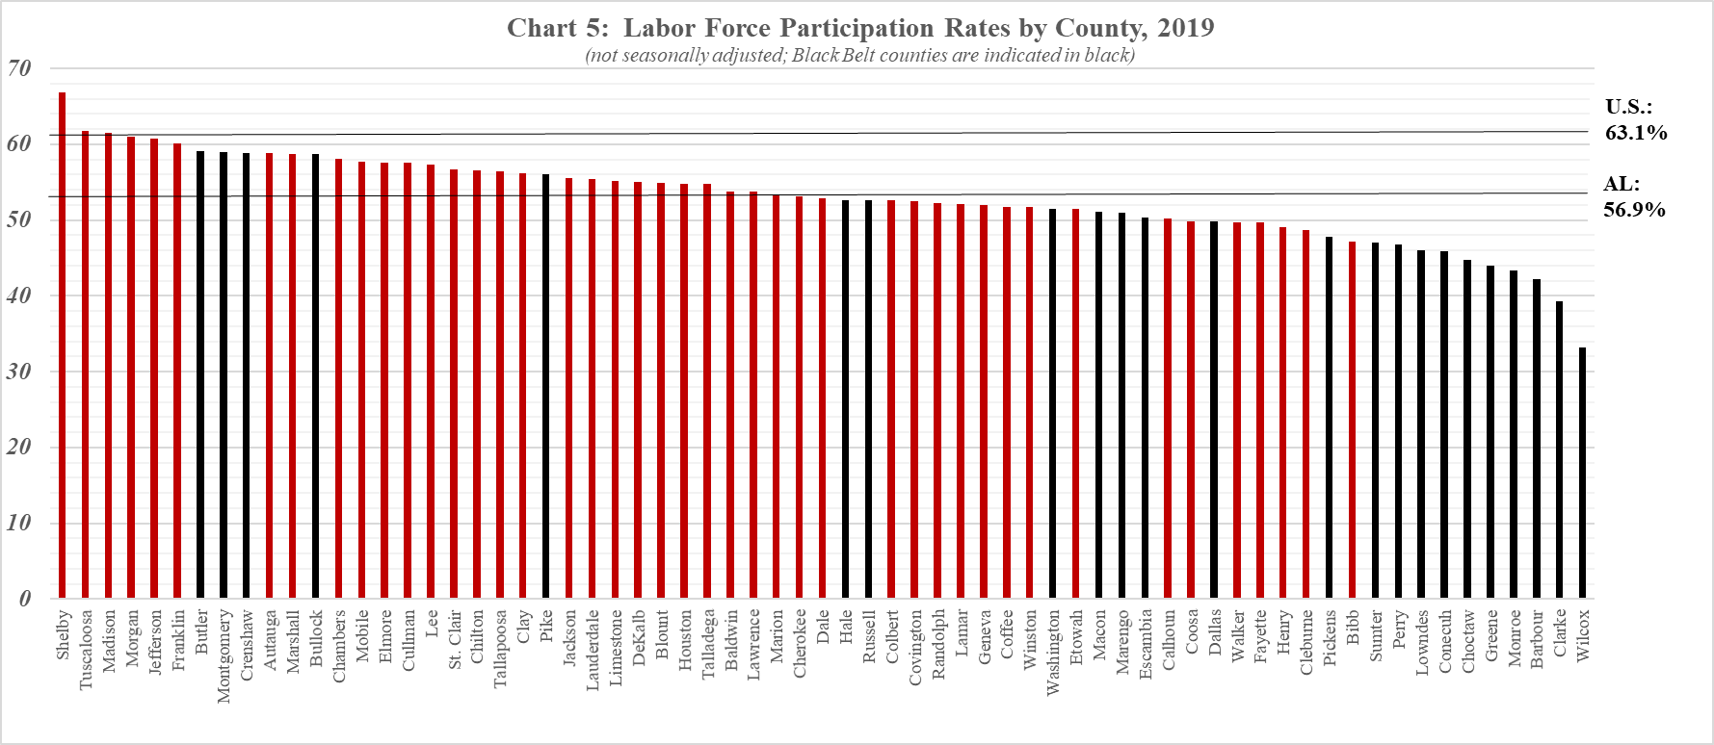
Labor Force Participation in Alabama Black Belt Counties in the Pandemic
Attention is now turned to specific county by county data. Chart 5 shows labor force participation rates for each of Alabama’s 67 counties in 2019. The data are not seasonally adjusted. Black Belt counties are indicated in black. When combined with the data presented above, it shows that Alabama has made progress in recent years, both statewide and in the Black Belt, but much more progress remains to be made to approach the national averages.
Charts 6 and 7 on the following page, provide an initial glimpse into labor force participation during the pandemic. Chart 6 presents the annual percentage change in labor force participation for all 67 Alabama counties comparing July 2019 to July 2020. Chart 7 isolates monthly data just for the 24 Black Belt counties, revealing a recent uptick in labor force participation of interest. This trend could be explained by a rise in the number of job seekers looking to support their families during the pandemic. To reiterate, labor force participation includes both employed and unemployed workers seeking jobs; while more Black Belt residents could be looking for jobs, it does not necessarily mean they are finding them. This issue deserves further investigation.

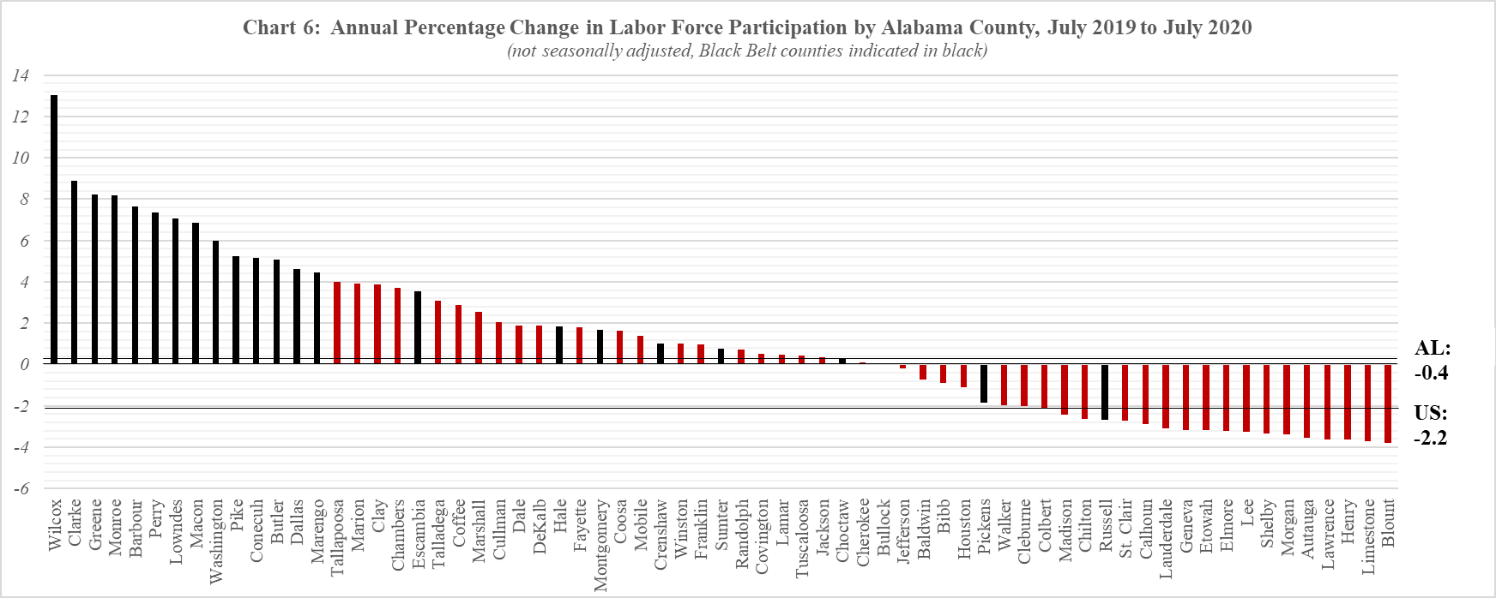

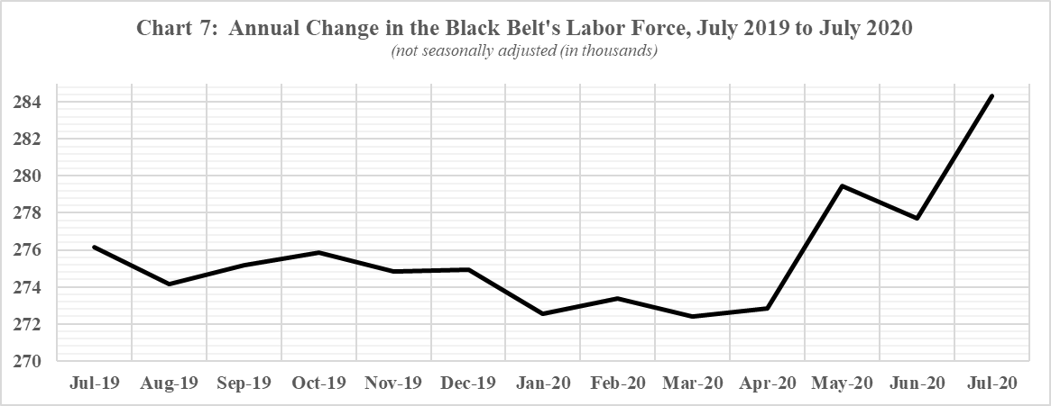
Reflecting on the Rural-Urban Divide
As with many other aspects of American life, a wide chasm exists between rural and urban labor force participation rates. According to the U.S. Department of Agriculture, “Between 2008 and 2017 the rural labor-force participation rate fell by 4.1 percentage points, compared to a decline of 2.7 percentage points in urban areas.” A large factor is rural America’s aging-in-place population. When data were isolated for “prime age” adults—those aged 25 to 54—the labor participation rate remained 2.7 percent below 2008 levels, indicating that retiring workers were not the only issue holding rural American back. The U.S. Department of Agriculture’s 2019 edition of Rural American at a Glance points to lower educational attainment and higher disability rates, in addition to aging-in-place residents.

The geography of rural areas—distant as they are from urban centers—entails issues of access to internet access as well. Providing broadband is widely believed to be a key strategy in developing rural economies. A 2019 U.S. Chamber of Commerce Technology Engagement Center study found that “[digital] tools and technology boosted gross sales of rural small businesses by 17.2 percent during the past three years, the equivalent of $69.8 billion per year.” The report advocates expanded access to high-speed internet, mobile phone connectivity, information technology assistance, and courses in digital programs to help bridge the rural-urban economic divide. A forthcoming EPC issue will specifically explore broadband access in the Black Belt.

Conclusion
In our initial report on population in the Black Belt, even if Alabama does not lose a congressional seat following the 2020 Census, a comprehensive strategy to address the Black Belt is needed, or the state could lose two House seats in 2030. It is important to note that prior to the pandemic, other states were faced with the same demographic challenge of slower rural population growth rates. They too are focusing on strategies to bolster their labor force participation rates. Put differently, pandemic or not, other states are moving forward, and Alabama cannot be satisfied or content by being average.

Not only does the Black Belt region experience higher incidences of unemployment, data show the region’s labor force participation rate has consistently been 20 percentage points lower than the rest of Alabama and the nation for almost three decades. Such persistent low levels of participations in the region where Dr. King and John Lewis spent so much time clearly justifies state policy interest now.

Consideration should also be given to strategies to expand apprenticeship and Career and Technical Education partnership programs between rural high schools, community colleges, and industries. The Education Policy Center is currently working with the Alabama Office of Apprenticeships to provide research and technical assistance for the development of industry-recognized competency models, career lattices, and career pathways for occupations identified as in-demand, which, among others, form the infrastructure for curricula and assessment of apprenticeship programs. Providing higher per student CTE funding to give high schools and rural community college campuses resources to make up for the lack of economies of scale they clearly lack, and matching state grants to give new programs in small, rural communities more time for the programs to take root could wise state investments.
THE EDUCATION POLICY CENTER AT THE UNIVERSITY OF ALABAMA
Established in 1924, the Education Policy Center is The University of Alabama’s oldest center or institute. Through its ongoing nonpartisan research and programs, it seeks to assist the College of Education and the University to fulfill their mission to improve the quality of life for all Alabamians. The EPC promotes expanding access and success, strengthening equity, and advancing economic and community development with special emphasis on telling the story of the Deep South to policymakers in Alabama, the region and nation.
Since 2005, the EPC has received $6 million in grants and contracts for basic and applied research, analyses of education issues, and services for policymakers and practitioners. The Center has presented its research on multiple occasions on Capitol Hill, at the White House, and the U.S. Departments of Education and Agriculture. Since 2010, the EPC has conducted 21 studies of Pell Grants. The Center also participated in the successful advocacy of the re-instatement of year-round (Summer) Pell.
Ongoing projects include the National Access and Finance Survey; Alabama Transfers: a partnership with the University of Alabama’s Provost Office and Alabama’s Statewide Transfer Articulation and Reporting System to prevent loss of time, credits and money for transfer students; a partnership with the Governor’s Office of Education and Workforce Transformation to align the state’s education and workforce goals with business needs; and an issue briefs series in partnership with Al.com to raise awareness about Alabama’s impoverished Black Belt.
Director: Stephen G. Katsinas, Ph.D. Associate Director: Nathaniel Bray, Ph.D.
Project Coordinators/Managers: Brandi N. Stacey, Michael S. Malley, Jr.
Senior Fellow & Issue Briefs Editor: James E. “Ed” Davis, Ph.D. (Emeritus, Mississippi State University)
Associate Issue Briefs Editor: Phillip D. Grant, Ph.D. (University of West Georgia)
Senior Fellows: Arleene P. Breaux, Ph.D., James E. “Skip” Dotherow, Ph.D., Phillip D. Grant, Ph.D., Ray Huebschmann, Ph.D., Brian K. Johnson, Ph.D., Vincent A. Lacey, Ph.D., R. Frank Mensel, Ph.D., David Murphy, Ph.D.
Fellows: Mark D’Amico, Ph.D., Janice Friedel, Ph.D., Linda Hagedorn, Ph.D., and Michael Kennamer, Ph.D.
Research Associates: Stephanie Paul, Noel Keeney, John Bruno, Emily Jacobs, Hunter Whann, Emily Grace Corley, Brandon Glover, and Jonathan Bowen
Box 870231, Tuscaloosa, Alabama 35487 - Telephone: (205) 348-6005 - http://edpolicy.ua.edu

Governor Kay Ivey (2018, May 14). Governor Kay Ivey Announces “Success Plus” Initiative to Prepare State’s Workforce. Press Release. https://governor.alabama.gov/newsroom/2018/05/governor-kay-ivey-announces-success-plus-initiative-to-prepare-states-workforce/.
Alabama Workforce Council (2018, April 30). Preparing Alabama’s Workforce for Opportunity and Growth, Recommendations from the Alabama Workforce Council’s Statewide Educational Attainment Committee. https://alabamaworks.com/wp-content/uploads/2018-12-27-AWC-Attainment-Report_final.pdf.
Whann, H., Katsinas, S.G., Keeney, N.E., Jacobs, E.J. (2020 Sep 9). Persistent Unemployment in the Black Belt. The Education Policy Center at the University of Alabama. http://edpolicy.ua.edu/wp-content/uploads/2020/09/200908_persistent-unemployment-al-black-belt.pdf.
Ibid.
U.S. Bureau of Labor Statistics, Concepts and Definitions. https://www.bls.gov/cps/definitions.htm#unemployed.
U.S. Bureau of Labor Statistics, State and Local Unemployment Rates.
Ibid.
Katsinas, S.G., Keeney, N.E., Jacobs, E., Whann, H. (2020 Aug 18). The Black Belt’s Population Decline Explains Why Alabama May Lose a Congressional Seat in the 2020 Census. The Education Policy Center at the University of Alabama. http://edpolicy.ua.edu/wp-content/uploads/2020/08/200824_pop-decline-al-black-belt.pdf.
U.S. Department of Agriculture, Economic Research Service (2019 Sept 23). Rural Employment and Unemployment. https://www.ers.usda.gov/topics/rural-economy-population/employment-education/rural-employment-and-unemployment/#lfp.
U.S. Department of Agriculture, Economic Research Service (2019 November). Rural America at a Glance. https://www.ers.usda.gov/webdocs/publications/95341/eib-212.pdf?v=5832.
U.S. Chamber Technology Engagement Center, Unlocking the Digital Potential of Rural America. https://americaninnovators.com/wp-content/uploads/2019/03/Unlocking-the-Digital-Potential-of-Rural-America.pdf

