*Issue Brief No. 47*

**Access to Early Childhood Interventions and**

**First Class Pre-K in Alabama & the Black Belt Region**

by Hunter Whann, Noel E. Keeney,

Emily Jacobs, and Stephen G. Katsinas

In April of 2020, the National Institute of Early Education Research ranked the Alabama First Class Pre-K program as the highest quality state-funded pre-kindergarten program in the country for the 14th consecutive year.[1] “In 2019,” the Governor’s office announced, “Alabama First Class Pre-K received its largest-ever single year funding increase…which expanded pre-k access to more than 38% of four year-olds in the state.”[2] This issue brief, part of a series produced by the Education Policy Center at the University of Alabama, explores pre-k access across Alabama with special attention paid to the Black Belt region.

***The Earliest Intervention: First Teacher Home Visiting***

The Alabama Department of Early Childhood Education’s (ADECE) is making broad-based strides to promote school readiness, family and child health and well-being, and helping parents access resources in their own communities. The First Teacher Home Visiting program seeks to improve health outcomes for mothers and babies, reduce children’s emergency room visits, improve school readiness, reduce child injuries and reduce cases of child abuse and neglect. Three evidence-based home visiting models—Parents as Teachers (PAT), Nurse Family Partnership (NFP), and Home Instruction for the Parents of Preschool Youngsters (HIPPY)—are used to match families with trained professionals who provide support and information. Some programs can enroll pregnant women and continue to serve the family until the child enters kindergarten, with the home as the primary service delivery setting. First Teacher Home Visiting programs can provide telehealth services in both visits to the home and remote visits utilizing technology, including cell phones and iPads. This alternative way of “visiting” with parents is especially beneficial when it comes to serving millennial parents:

First Teacher serves some of Alabama’s most vulnerable families. Nearly two-thirds meet the federal definition for poverty and the majority of those are in extreme poverty, 50% or less of the poverty threshold. 65% of families served by First Teacher Home Visiting are single-parent homes. In 2018, 2,477 children received home visiting services with a focus on supporting the child’s growth and development. 1,467 families engaged in efforts to increase parent-child interactions that include enriching learning experiences in the home. Overall, 50,000 home visits were provided, offering families a foundation for future success through support, strategies, and relevant community resources. The First Teacher Home Visiting program saw marked improvements in tobacco cessation efforts. Through 22 First Teacher programs using the HIPPY model, almost 2,000 children received home-based instruction from parents or guardians, committed to increasing literacy and parent-child interactions in the home.[3]

Chart 1, left, shows the percentage of households with children that are single parent households by county. The data show markedly higher rates of single parents in the Black Belt. As the EPC previously researched, the region has experienced high rates of unemployment for decades.[4] These two factors combined make for a precarious position for countless children.

***Partnerships and Infant and Early Childhood Mental Health***



The ADECE’s alignment efforts have increased collaboration and partnerships among early childhood agencies and providers. The ADECE’s partnerships include the Alabama State Department of Education, the Alabama Department of Child Abuse and Neglect Prevention (CANP), the Alabama Department of Mental Health (ADMH), the Alabama Department of Human Resources (DHR) and the non-profit group Alabama Partnership for Children (APC). There are now more than 20 Infant and Early Childhood Mental Health endorsed professionals across ADECE. There is now also an Early Childhood Development team with mentor coaches and specialized infant-toddler coaches. Meanwhile, Alabama has joined the international Alliance for the Advancement of Infant Mental Health, a consortium of 25 states, Australia, and Ireland with the goal of positioning efforts in developing the early childhood workforce that can earn nationally recognized endorsements, increase services, and expand services access to the state’s infant and toddler population. A new position, State Coordinator for Infant and Early Childhood Mental Health, was created in partnership with ADMH the state’s lead agency for Project LAUNCH (Linking Actions for Unmet Needs in Children’s Health), to address the need for system-wide change across the state. Clearly, the state of Alabama has made the care and education of its future citizens and workforce development a high priority.

***Narrowing Achievement Gaps with First Class Pre-K***

As these investments have spread more widely across the state, achievement gaps are narrowing. A study of third graders found that in both reading and math proficiency, First Class Pre-K narrowed achievement gaps between children in poverty and more affluent peers, and between minority children and non-minority children. Children in poverty receiving First Class Pre-K consistently outperformed their peers who did not, with the largest gains observed for Black and Hispanic children. First Class Pre-K closed the gap in reading proficiency by 28% for children in poverty compared to statewide proficiency levels, with a 12% gain (increase) in reading proficiency. First Class Pre-K closed the gap in math proficiency by 57% for children in poverty compared to statewide proficiency levels, with a 13% gain (increase) in math proficiency.[5]

Chart 1 on the following page shows the status of First Class program access in Alabama in 2019-2020. Of the 24 Black Belt counties, four—Escambia, Lamar, Lowndes, and Pike—had less than 37% of their four-year-olds enrolled in what the ADECE has defined as First-Class Pre-K programs. Data were researched by the University of Alabama at Birmingham’s School of Public Health.

In the longer term, it is important to collect objective data on what children know and can do, each year, and in particular, to measure the educational, physical and social developmental levels of children, from the ages of 4 to 7. ADECE utilizes the Teaching Strategies GOLD assessment to survey 38 objectives across six domains associated with school success.[6] Positive results for First Class Pre-K participants include:

* Fewer than 50% of children arrived in First Class Pre-K meeting development and learning predictors of school success. However, by the end of the year, nearly all were meeting or exceeding expectations. Across social-emotional, physical, language, cognitive, literacy, and mathematics tests, upon entry in Fall 2018, students in First Class Pre-K averaged about 45 percent, improving to about 90 percent by the exit testing in the Spring 2019.
* In both reading and mathematics, there was a29.6% gap in proficiency between poverty and non-poverty students, First Class Pre-K closes this gap.
* Children who received First Class Pre-K had lower rates of absenteeism, and fewer of the children were in need of special education services.
* As of Fall 2019, 8.7% of children participating in First Class Pre-K were retained at least once between kindergarten and the seventh grade, 3.2 points lower than the 11.9% retained with no First Class Pre-K--a one-fourth reduction in retention, or 13,763 fewer children retained, with an estimated potential cost savings of $126,798,519.[7]

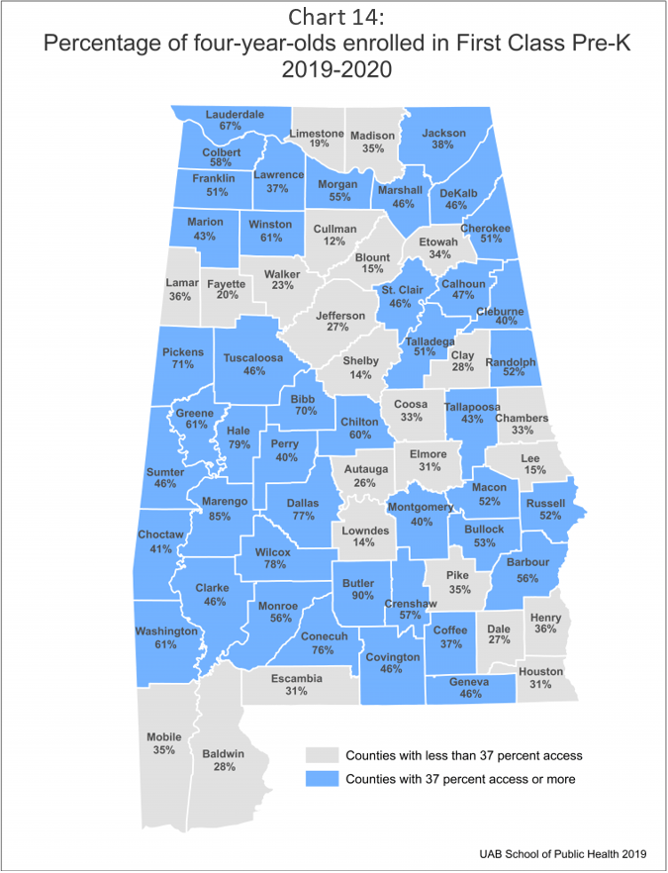Source: Alabama Department of Early Childhood Education[8]



2:

The number of First Class Pre-K classrooms across the state has steadily grown over the years from 281 in 2013 to over 1,200 in 2019.[9] The Ivey administration announced in May 2020 the addition of another 55 classrooms, bringing the total to over 1,250—an increase of 350%since 2013.[10] At the same time, the percentage of 4-year-olds in Alabama with access to First Class Pre-K has nearly tripled from 13% in 2014 to 37% in 2019.[11] Chart 3, below, shows the average number of children under 5 by per First Class Pre-K classroom by county. In the case of the Black Belt, generally lower population means a lower (more desirable) number of students per classroom. Actual access, however, is harder to determine given long travel times—a subject for further research.

***Census Concerns***

The Education Policy Center’s recent brief posited that the Black Belt’s population decline may explain the prospective loss of a congressional seat for Alabama.[12] At the same time, more than $13 billion in federal assistance for Alabama is at stake.[13] In 2015, federal obligations for the Head Start/Early Head Start program totaled close to $132 million, while the Supplemental Nutrition Program for Women, Infants, and Children totaled just over $113 million.[14] While these federal dollars relate specifically to early education efforts, hundreds of millions more go to K-12 education. With the pandemic challenging the Census count, these funds may be jeopardized.

***Conclusion***

Recent EPC briefs have examined issues such as population decline[15] and persistent unemployment[16] in the Black Belt. In this instance, pronounced efforts on the part of the Alabama state government to develop its nationally preeminent First Class Pre-K program gives cause for optimism. While federal assistance may be jeopardized by low Census participation, such a program represents an invaluable investment in the state’s future and is poised to pay dividends in terms of economic and social development.

**THE EDUCATION POLICY CENTER AT THE UNIVERSITY OF ALABAMA**

**Established in 1924, the Education Policy Center is The University of Alabama’s oldest center or institute. Through its ongoing nonpartisan research and programs, it seeks to assist the College of Education and the University to fulfill their mission to improve the quality of life for all Alabamians. The EPC promotes expanding access and success, strengthening equity, and advancing economic and community development with special emphasis on telling the story of the Deep South to policymakers in Alabama, the region and nation.**

**Since 2005, the EPC has received $6 million in grants and contracts for basic and applied research, analyses of education issues, and services for policymakers and practitioners. The Center has presented its research on multiple occasions on Capitol Hill, at the White House, and the U.S. Departments of Education and Agriculture. Since 2010, the EPC has conducted 21 studies of Pell Grants. The Center also participated in the successful advocacy of the re-instatement of year-round (Summer) Pell.**

**Ongoing projects include the National Access and Finance Survey; Alabama Transfers: a partnership with the University of Alabama’s Provost Office and Alabama’s Statewide Transfer Articulation and Reporting System to prevent loss of time, credits and money for transfer students; a partnership with the Governor’s Office of Education and Workforce Transformation to align the state’s education goals with the needs of its workforce; as well as a series of issue briefs in partnership with Al.com to raise awareness about the persistently impoverished Black Belt region of Alabama.**

**Director:** Stephen G. Katsinas, Ph.D. **Associate Director:** Nathaniel Bray, Ph.D.

**Project Coordinators/Managers**: Brandi N. Stacey, Michael S. Malley, Jr.

**Senior Fellow & Issue Briefs Editor**: James E. “Ed” Davis, Ph.D. (Emeritus, Mississippi State University)

**Associate Issue Briefs Editor:** Phillip D. Grant, Ph.D. (University of West Georgia)

**Senior Fellows:** Arleene P. Breaux, Ph.D., James E. “Skip” Dotherow, Ph.D., Phillip D. Grant, Ph.D., Ray Huebschmann, Ph.D., Brian K. Johnson, Ph.D., Vincent A. Lacey, Ph.D., R. Frank Mensel, Ph.D., David Murphy, Ph.D.

**Fellows:** Mark D’Amico, Ph.D., Janice Friedel, Ph.D., Linda Hagedorn, Ph.D., Michael Kennamer, Ph.D., Dustin Smith, Ph.D.

**Research Associates:** John Bruno, Emily Grace Corley, Brandon Glover, Emily Jacobs, Noel Keeney, Stephanie Paul, Hunter Whann, Jonathan Bowen

**Box 870231, Tuscaloosa, Alabama 35487 - Telephone: (205) 348-6004 - http://edpolicy.ua.edu**

1. The Office of Alabama Governor Kay Ivey. (2020 Apr 22). *Governor Ivey Announces Alabama First Class Pre-K Continues Leading the Nation in Quality, Increases Pre-K Enrollment* [Press release]. Retrieved from https://governor.alabama.gov/newsroom/2020/04/governor-ivey-announces-alabama-first-class-pre-k-continues-leading-the-nation-in-quality-increases-pre-k-enrollment/.
2. *Ibid.*
3. Alabama Department of Early Childhood Education, Annual Report (2019 Feb). Available at: http://children.alabama.gov/wp-content/uploads/sites/4/2019/03/DECE-Annual-Report-Feb-2019.pdf.
4. Whann, H., Katsinas, S.G., Keeney, N.E., Jacobs, E.J. (2020 Sep 9). *Persistent Unemployment in the Black Belt*. The Education Policy Center at the University of Alabama. Available at http://edpolicy.ua.edu/wp-content/uploads/2020/09/200908_persistent-unemployment-al-black-belt.pdf.
5. *Ibid.*
6. Alabama Department of Early Childhood Education (2017 Apr). First Class Pre-K Issue Brief. *School Readiness at Kindergarten Entry: Differences between Students Who Participated in First Class Pre-K and Those Who Did Not, Fall 2016*. Retrieved at http://children.alabama.gov/wp-content/uploads/sites/4/2017/07/KEA_4-27-17.pdf.
7. Ross, Jeana (2020). 2020 Legislative Presentation [PowerPoint slides]. Retrieved from http://children.alabama.gov/wp-content/uploads/sites/4/2020/01/2020-Legislative-Presentation_Final.pdf.
8. Alabama Department of Early Childhood Education, Statewide Access and Program Maps 2019-2020. Retrieved at http://children.alabama.gov/adece-maps/.
9. Alabama Department of Early Childhood Education, 2019-2020 Data Snapshot. Retrieved from http://children.alabama.gov/wp-content/uploads/sites/4/2019/11/Alabama-Data-Snapshot-2019.pdf.
10. The Office of Alabama Governor Kay Ivey (2020 May 19). *Governor Ivey Announces Alabama First Class Pre-K Program Adding 55 New Classrooms in 25 Counties* [Press release]. Retrieved from https://governor.alabama.gov/newsroom/2020/05/governor-ivey-announces-alabama-first-class-pre-k-program-adding-55-new-classrooms-in-25-counties/.
11. Alabama Department of Early Childhood Education, 2019-2020 Data Snapshot.
12. Katsinas, S.G., Keeney, N.E., Jacobs, E., Whann, H. (2020 Aug 18). *The Black Belt’s Population Decline Explains Why Alabama May Lose a Congressional Seat in the 2020 Census*. The Education Policy Center at the University of Alabama. Available at http://edpolicy.ua.edu/wp-content/uploads/2020/08/200824_pop-decline-al-black-belt.pdf.
13. Governor Kay Ivey. (2020, Apr 1). *Gov. Ivey Encourages Alabamians to Complete 2020 Census* [video]. Youtube. https://www.youtube.com/watch?v=COo3wN0ZItQ&feature=emb_logo. 
14. Alabama Counts! (2020) *How will the 2020 Census benefit your schools?* Available at https://census.alabama.gov/education/.
15. Katsinas, S.G., Keeney, N.E., Jacobs, E., Whann, H. (2020 Aug 18). *The Black Belt’s Population Decline Explains Why Alabama May Lose a Congressional Seat in the 2020 Census*. The Education Policy Center at the University of Alabama. Available at http://edpolicy.ua.edu/wp-content/uploads/2020/08/200824_pop-decline-al-black-belt.pdf.
16. Whann, H., Katsinas, S.G., Keeney, N.E., Jacobs, E.J. (2020 Sep 9). *Persistent Unemployment in the Black Belt*. The Education Policy Center at the University of Alabama. Available at http://edpolicy.ua.edu/wp-content/uploads/2020/09/200908_persistent-unemployment-al-black-belt.pdf.