Issue Brief № 50

Internet Access Disparities in

Alabama & the Black Belt
  - By Stephen G. Katsinas, Noel E. Keeney,
Emily Jacobs, Emily Grace Corley, and Hunter Whann
  - “Farmers and other rural Alabamians are at a significant disadvantage without high-speed internet access. This pandemic illustrates many of those problems, particularly those who need access to telehealth services, as well as employees and students who need to stay connected.”
—President Jimmy Parnell, Alabama Farmers Association

Since the beginning of the pandemic, millions of Pre-K, elementary, secondary, and post-secondary students and instructors throughout the country have had to adapt to online learning. While many today take broadband and wi-fi access for granted, there remains a significant number of Americans—particularly those in rural areas—who struggle to find a connection. This issue brief, part of a series produced by the University of Alabama’s Education Policy Center, presents original data on internet access in Alabama with particular interest in the Black Belt region. National trends are also examined, with potential solutions explored.

The Black Belt Lags Behind in Access to Broadband
Alabama’s Black Belt region is markedly behind the rest of the state when it comes to internet access. Chart 1 on the following page shows the percentage of the population by country who enjoy access to 100+ megabits per second (mbps) broadband as of 2020. Of the 24 Black Belt counties found by EPC in various reports to be part of the region, all except two are below the statewide average of 86 percent coverage, and half are below 50 percent. Further, Choctaw and Perry counties zero percent coverage of 100+ mbps internet (Greene County has a negligible 0.02 percent coverage).

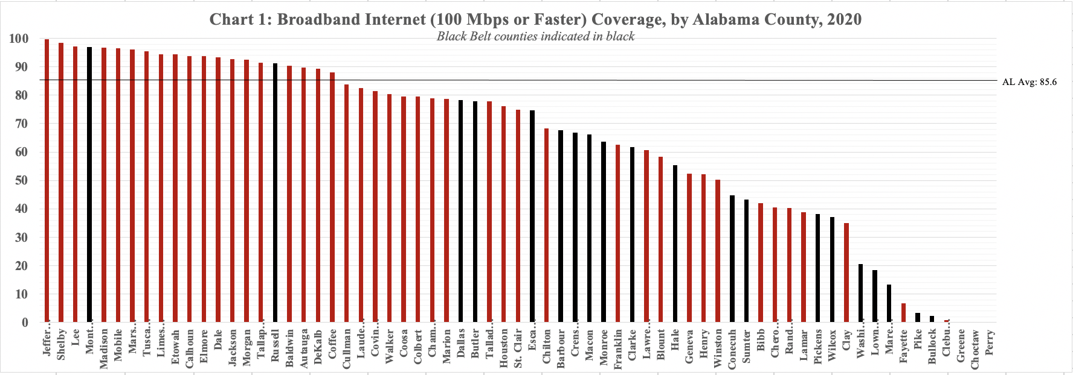
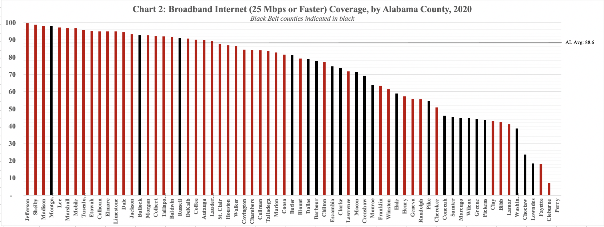

Chart 2, above, displays similar mbps data but at a much lower speed. While access levels are above 100+ mbps levels, the overall standing of the Black Belt remains similar. Three Black Belt counties are above the Alabama average of 89 percent coverage, while 10 are at 50 percent or below.
“The global COVID-19 pandemic,” says Perry County Commission Chairman Cedric Hudson, “is exposing one of the many problems in poor rural counties like Perry County—internet access is simply lacking or nonexistent…[poor] internet is limiting the knowledge and quality of life for the citizens in Perry county and all rural counties in the state.” University of Alabama student and Education Policy Center intern Branden Glover, a native of Linden, Marengo County, struggled to continue his studies at home in the Black Belt. Interviewed for this issue brief, Mr. Glover attested to the lack of high-speed broadband in rural Alabama: “It has been quite a difficult challenge,” he explained, “due mainly to the fact that internet access where I stay is either working [in] poor condition or not at all. Thus, making it nearly impossible to get work or other tasks done.”
BroadBandNow, an internet access policy research center, ranks Alabama 38th in the nation for broadband access. “While the northern and east-central parts of Alabama, as well as the southwest tip of the state, are relatively well-connected,” BroadbandNow reports, “there remain a number of counties with low broadband coverage.” The area just described is essentially the Black Belt. The policy center spotlights availability and affordability as the two main factors contributing to the “digital divide” in Alabama. The former was discussed in connection to Charts 1 and 2. Regarding the latter, data show only 44.4 percent of Alabamians have access to an “affordable” internet plan of $60 or less per month. In other words, a majority of the state’s residents lack access to affordable internet—a twenty-first century necessity for business, education, and communication—and most those Alabamians are in the Black Belt.

Alabama is Investing to Expand Access
“While expansion was already a priority,” writes Josh Moon of Alabama Political Reporter, “[Senate President Del] Marsh said the pandemic has now made it the top priority.” In March of 2018, Governor Kay Ivey signed into law the Alabama Broadband Accessibility Act, creating the Alabama Broadband Accessibility Fund to expand access to underserved communities—a major step in addressing the issue. Just this year, the Ivey Administration has awarded millions of dollars in grants and other targeted funding to expand internet access in Alabama. In March, Gov. Ivey awarded $9.5 million in broadband expansion grants, with a significant amount going to Black Belt communities. This was followed by $5.1 million in additional grants in May. Thanks to the Broadband Accessibility Fund and broadband providers,” Governor Ivey announced, “we are making progress in ensuring that Alabamians have access to high-speed internet services.” She continued: “[But] there is no question we have a long way to go on completing this mission.”
The State of Alabama also allocated $100 million in federal CARES Act-related dollars for “equipment and service for broadband, wireless hot spots, satellite, fixed wireless, DSL, and cellular-on-wheels” to increase access for K-12 students undergoing distance learning. An additional $100 million in CARES funding was allocated for local education agencies to facilitate virtual learning for Alabama’s public school students, as well as $72 million for higher education. Recent federal assistance to expand internet access has bolstered a steady stream of investment by the State of Alabama to ensure widespread access to broadband.

Broadband Expansion Efforts in Rural Alabama
In addition to public investments to expand broadband in rural Alabama, there are also ongoing private efforts to bring broadband to underserved rural areas. Currently, there is a movement building among rural electric cooperatives to tie existing electric systems to highspeed fiber internet networks and bring this critical service to rural Alabamians. The Alabama Rural Electric Association of Cooperatives (AREA) includes 22 member distribution co-ops across the state of Alabama plus PowerSouth, a generation and transmission co-op, with 10 distribution members serving Black Belt counties. Much like how rural electric co-ops paved the way for rural electrification in the 1930s and 1940s, these same community-based organizations have the opportunity to bring rural Alabama into the 21st century.
Of the 22 AREA members, three organizations have already begun efforts to bring fiber internet access to the people in their service areas: Cullman Electric, Central Alabama Electric, and Tombigbee Electric. Only Central Alabama Electric serves residents of the Black Belt, but the model used by these organizations could be applied to the other 9 co-ops serving the region. Each project has received grant funding to create fiber internet networks from sources such as the Alabama Broadband Accessibility Fund and the U.S. Department of Agriculture’s Rural Utilities Service. Between these projects, thousands of miles of fiber cables will be strung or laid to bring highspeed (100 mbps+) internet to thousands of rural Alabamians over the course of the next few years.

Internet Access & Healthcare During a Pandemic
The COVID-19 pandemic has brought telehealth into the spotlight like never before. The Mayo Clinic defines telehealth as “the use of digital information and communication technologies, such as computers and mobile devices, to access healthcare services remotely and manage your health care.” Its use has skyrocketed from just 11 percent of US consumers in 2019 to 46 percent as of May 2020, with 76 percent of Americans interested in using it going forward. If this trend continues after the pandemic, the telehealth industry could see its value rise from an estimated $3 billion as of 2019, up to $250 billion as healthcare expenditures are “virtualized.” Telehealth is indeed important like never before.
Of course, telehealth by its very definition requires an internet connection—which as this brief has shown puts many at an instant disadvantage. The Education Policy Center’s issue brief on healthcare showed significant disparities in access in rural areas like the Black Belt. As discussed in this issue brief, the 24 Black Belt counties are also among the least internet-connected parts of the state. Of the $1.9 billion provided to the State of Alabama in COVID-19 relief, $300 million has been designated for remote learning technology and infrastructure—which could ostensibly assist telehealth. The Federal Communications Commission has more directly assisted telehealth, awarding UAB $1 million in July “to purchase iPads, webcams, and remote patient monitoring devices to facilitate the huge increase in telehealth that UAB has experienced.” Similar US Department of Agriculture grant awards of $72 million to expand telehealth access infrastructure—i.e. broadband—nationally, $3 million of which was awarded to Alabama specifically, speak imperatively to the nature of internet access as a first-order issue for other public policy challenges.

Broadband Access is a National Issue
Students and instructors across the country are adapting to new policies and procedures designed to mitigate the spread of COVID-19, but many are at a disadvantage due to a lack of easy access to the internet. The Atlanta Journal Constitution reported in April how some college students were relying on fast food restaurants for wi-fi. They had to “sit in the local parking lot to connect to free Wi-fi—often unreliable and unstable—to complete assignments.” A University of Georgia student is quoted “[our] grading system assumes that we have similar access to resources to complete our education…that just isn’t true.” Elementary and secondary students are also struggling to get the education they need because of inconsistent internet access. A Los Angeles Times editorial explained “the same old problems—lack of internet access or computers for doing homework…are exacerbated now that students are required to learn not in a classroom, but remotely.” This is especially true in rural schools that lack the funds to assist its students.
Nationally, expanding broadband access is a high priority for the federal government. In March 2020, President Trump signed into law the Broadband Deployment Accuracy and Technological Available (DATA) Act. According to the Benton Institute for Broadband & Society, the law “requires the [Federal Communications Commission] to adopt new rules… that mandates the biannual collection, verification, and dissemination of granular data relating to the availability and quality of service with respect to terrestrial fixed, fixed wireless, satellite, and mobile broadband internet access service, from which the FCC will compile broadband coverage maps.” It also requires the FCC to create and update a common dataset for all locations in the U.S. where fixed broadband service can be installed, meant to focus its efforts in rural and insular areas. By mapping where in the country internet is unavailable, the FCC will then be able to pinpoint areas for broadband to be installed and made accessible. This is a huge development for residents in areas like Alabama’s Black Belt who cannot today enjoy the benefits of internet access.

Conclusion
The digital divide, initially identified in the late 1990s, has clearly existed since the introduction of the internet to society at-large. This stark divide has been laid bare and called to attention by the COVID-19 pandemic. With millions of students at all levels and in all education sectors now having to adapt to remote learning, a significant number will be left behind due to lack of internet access. Rural areas like Alabama’s Black Belt are particularly hard-hit as lack of access to the internet—combined with other issues like population decline, high unemployment, and strained healthcare access— is forcing residents to leave. This issue will remain after the pandemic has passed, underscoring the importance of formulating policy to ensure the broadest access to internet possible for Americans.

The Education Policy Center at the University of Alabama
Established in 1924, the Education Policy Center is The University of Alabama’s oldest center or institute. Through its ongoing nonpartisan research and programs, it seeks to assist the College of Education and the University to fulfill their mission to improve the quality of life for all Alabamians. The EPC promotes expanding access and success, strengthening equity, and advancing economic and community development with special emphasis on telling the story of the Deep South to policymakers in Alabama, the region and nation.
Director: Stephen G. Katsinas, Ph.D. Associate Director: Nathaniel Bray, Ph.D.
Project Coordinators/Managers: Brandi N. Stacey, Michael S. Malley, Jr.
Senior Fellow & Issue Briefs Editor: James E. “Ed” Davis, PhD (Emeritus, MS State University)
Associate Issue Briefs Editor: Phillip D. Grant, Ph.D. (University of West Georgia)
Senior Fellows: Arleene P. Breaux, Ph.D., James E. “Skip” Dotherow, Ph.D., Phillip D. Grant, Ph.D., Ray Huebschmann, Ph.D., Brian K. Johnson, Ph.D., Vincent A. Lacey, Ph.D., R. Frank Mensel, Ph.D., David Murphy, Ph.D., J. Warner
Fellows: Mark D’Amico, Ph.D., Janice Friedel, Ph.D., Linda Hagedorn, Ph.D., Michael Kennamer, Ph.D., Dustin Smith, Ph.D.
Research Associates: John Bruno, Emily Grace Corley, Brandon Glover, Emily Jacobs, Noel Keeney, Stephanie Paul, Hunter Whann, and Jonathan Bowen
Box 870231, Tuscaloosa, Alabama 35487 · Telephone: (205) 348-6004 · http://edpolicy.ua.edu

References

Davis, D. (2020 Mar 19). Students and Employees Go Online, Highlighting Need for Broadband Access. Alabama Farmers Federation. https://alfafarmers.org/students-and-employees-go-online-highlighting-need-for-broadband-access/.
Katsinas, S.G., Keeney, N.E., Jacobs, E., Whann, H. (2020 Oct 6). Alabama can’t agree which counties are in the Black Belt— and that’s a problem. The Education Policy Center at the University of Alabama.
Alabama Rural Broadband Coalition [Rolling banner]. https://www.alruralbroadband.com.
B. Glover (personal communication, 2020 Apr).
BroadbandNow. (2020 Sep 1). Internet Access in Alabama. https://broadbandnow.com/Alabama.
Ibid.
Ibid.
Moon, J. (2020 Aug 26). Lawmakers: Broadband access most important issue facing Alabama. Alabama Political Reporter. https://www.alreporter.com/2020/08/26/lawmakers-broadband-access-most-important-issue-facing-alabama/.
Office of Alabama Governor Kay Ivey. (2018 Mar 28). Governor Ivey Signs Alabama Broadband Accessibility Act [Press release]. Retrieved from https://governor.alabama.gov/newsroom/2018/03/governor-ivey-signs-alabama-broadband-accessibility-act/.
Office of Alabama Governor Kay Ivey. (2020 Mar 31). Gov. Ivey awards $9.5 million in broadband expansion grants [Press release]. Retrieved from https://governor.alabama.gov/newsroom/2020/03/gov-ivey-awards-9-5-million-in-broadband-expansion-grants/.
Koplowitz, H. (2020 May 26). Ivey awards $5.1 million to expand high-speed internet in rural Alabama. Al.com. https://www.al.com/news/2020/05/ivey-awards-51-million-to-expand-high-speed-internet-in-rural-alabama.html.
The Office of Alabama Governor Kay Ivey, Press Releases. (2020, July 16). Gov. Ivey awards broadband grants for 7 projects in Alabama [Press release]. https://governor.alabama.gov/newsroom/2020/07/gov-ivey-awards-broadband-grants-for-7-projects-in-alabama/.
Office of Alabama Governor Kay Ivey. (2020 July 31). Governor Ivey Allocates $100 Million for Alabama Broadband Connectivity for Students [Press release]. Retrieved at https://governor.alabama.gov/newsroom/2020/07/governor-ivey-allocates-100-million-for-alabama-broadband-connectivity-for-students/.
Office of Alabama Governor Kay Ivey. (2020 July 20). Governor Ivey Announces $170 million for Health Care and Remote Learning in Alabama Public Schools [Press release]. Retrived from https://governor.alabama.gov/newsroom/2020/07/governor-ivey-announces-170-million-for-health-care-and-remote-learning-in-alabama-public-schools/.
Wood, C. (2020 Sep 11). Alabama universities get $72 million for remote-learning tech. EdScoop. https://edscoop.com/alabama-universities-72-million-remote-learning-tech/.
Alabama Rural Electric Association of Cooperatives. Who We Are. https://areapower.coop/who-we-are/.
Alabama Rural Electric Association of Cooperatives. Co-op History. https://areapower.coop/who-we-are/co-op-history/.
Central Alabama Electric Cooperative. CAEC Awarded Rural Broadband Grants. https://caec.coop/news/caec-awarded-rural-broadband-grants/.
Alabama Rural Electric Association of Cooperatives. Tombigbee Communications receives a grant for rural broadband expansion. https://areapower.coop/tombigbee-communications-receives-grant-for-rural-broadband-expansion/.
Mayo Clinic Staff. (2020 May 15). Telehealth: Technology meets health care. https://www.mayoclinic.org/healthy-lifestyle/consumer-health/in-depth/telehealth/art-20044878.
Bestsennyy, O., Gilbert, G., Harris, A., Rost, J. (2020 May 29). Telehealth: A quarter-trillion-dollar post-COVID-19 reality? McKinsey & Company. https://www.mckinsey.com/industries/healthcare-systems-and-services/our-insights/telehealth-a-quarter-trillion-dollar-post-covid-19-reality#.
Ibid.
Jacobs, E., Whann, H., Corley, E.G., Bowen, J., Keeney, N. (2020 Oct 13). Healthcare: A Key Challenge in Alabama’s Black Belt. The Education Policy Center at the University of Alabama. Available at http://edpolicy.ua.edu/wp-content/uploads/2020/10/201014_healthcare-challenge-al-black-belt.pdf.
Gainer, H. (2020 July 1). Carver, Wallace appointed by Ivey to Broadband Working Group for CARES Act funding. UAB News. https://www.uab.edu/news/people/item/11415-carver-wallace-appointed-by-ivey-to-broadband-working-group-for-cares-act-funding.
Shepard, B. (2020 July 8). UAB awarded $1 million for COVID-19 telehealth efforts. UAB News. https://www.uab.edu/news/health/item/11422-uab-awarded-1-million-for-covid-19-telehealth-efforts.
Moseley, B. (2020 Oct 8). USDA awards $3 million in grants for Alabama distance learning, telemedicine infrastructure. Alabama Political Reporter. https://www.alreporter.com/2020/10/08/usda-awards-3-million-in-grants-for-alabama-distance-learning-telemedicine-infrastructure/.
Downey, M. (2020, Apr 9). College students struggling with internet access say Georgia needs a pass/fail option. Atlanta Journal Constitution. https://www.ajc.com/blog/get-schooled/rural-students-without-doing-school-work-chick-fil-parking-lot/n4Fu1cVrDHghJnPUxxijjO/.
Ibid.
Editorial Board (2020, Apr 2). School shutdowns threaten to worsen the achievement gap. Los Angeles Times. https://www.latimes.com/opinion/story/2020-04-02/school-shutdowns-threaten-to-worsen-the-achievement-gap.
Benton Institute for Broadband & Society. (2020, Mar 27). Congress Tells FCC to Fix Broadband Maps Now. https://www.benton.org/blog/congress-tells-fcc-fix-broadband-maps-now?utm_source=sendgrid&utm_medium=email&utm_ campaign=Newsletters.
Katsinas, S.G., Keeney, N.E., Jacobs, E., Whann, H. (2020 Aug 18). The Black Belt’s Population Decline Explains Why Alabama May Lose a Congressional Seat in the 2020 Census. The Education Policy Center at the University of Alabama. Available at http://edpolicy.ua.edu/wp-content/uploads/2020/08/200824_pop-decline-al-black-belt.pdf.
Whann, H., Katsinas, S.G., Keeney, N.E., Jacobs, E.J. (2020 Sep 9). Persistent Unemployment in the Black Belt. The Education Policy Center at the University of Alabama. Available at http://edpolicy.ua.edu/wp-content/uploads/2020/09/200908_persistent-unemployment-al-black-belt.pdf.
Jacobs, E., Whann, H., Corley, E.G., Bowen, J., Keeney, N. (2020 Oct 13). Healthcare: A Key Challenge in Alabama’s Black Belt. The Education Policy Center at the University of Alabama. Available at http://edpolicy.ua.edu/wp-content/uploads/2020/10/201014_healthcare-challenge-al-black-belt.pdf.

